Cloud Computing

(COCSC15)



Submitted By:

INDEX

Google Workspace 2

Introduction 2

Included services 2

Security and Privacy 6

Pricing 6

VMWARE Cloud 7

Introduction 7

Cloud Architecture 10

Virtualization 11

Amazon Web Services (AWS) 12

AWS Use Cases 13

Billing 15

Related services 16

IAM 16

Extensive Documentation 17

Microsoft Azure 18

Introduction 18

Services 18

Login and Portal 19

Design and Deployment Model 20

Services 21

QuickStart Centre 21

App Services 22

AI and Machine Learning 22

Pricing 23

Meghraj 24

Introduction 24

Deployment Model 25

Services O"ered 25

Recently Hosted e-Gov Applications on NIC Cloud 27

Hands-On Experience 28

# Google Workspace

### Introduction

**Google Workspace** (formerly known as **Google Apps** and later **G Suite**) is a collection of cloud computing, productivity and collaboration tools, software and products as a service (**SaaS**) developed and marketed by Google. It was first launched in 2006 as Google Apps for “Your Domain” and rebranded as G Suite in 2016.

### Included services

Google Workspace consists of the following:

* Gmail, Contacts, Calendar, Meet and Chat for communication
* Currents for employee engagement
* Drive for storage
* Google Docs suite for content creation

An Admin Panel is provided for managing users and services. Depending on edition Google Workspace may also include the digital interactive whiteboard **Jamboard** and an option to purchase such add-ons as the telephony service Voice. The education edition adds a learning platform **Google Classroom** and today has the name Workspace for Education.

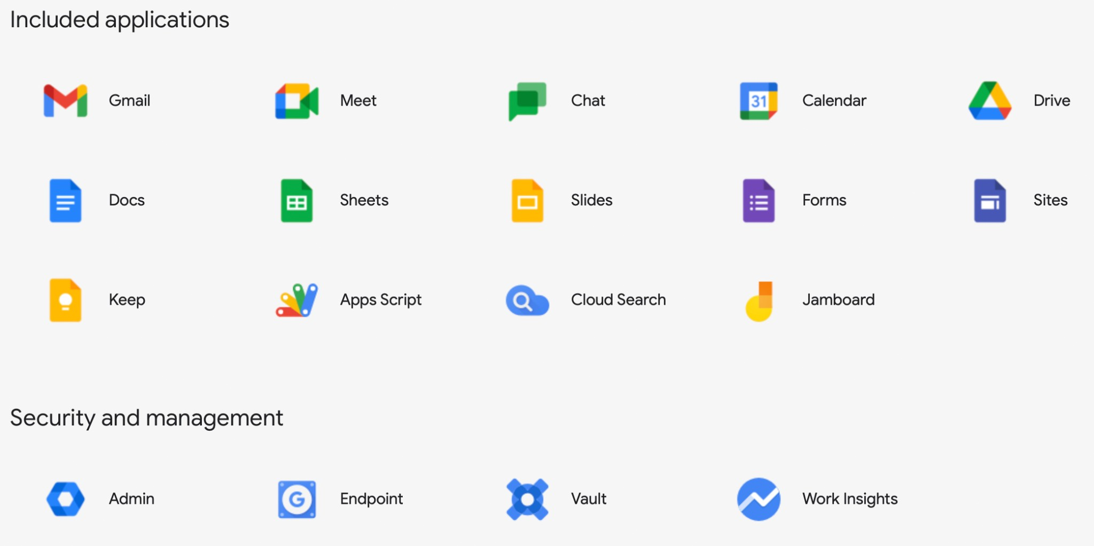

While most of these services are individually available at no cost to consumers who use their free Google (Gmail) accounts, **Google Workspace adds enterprise features** such as custom email

addresses at a domain (e.g. @yourcompany.com), an option for unlimited Drive storage, additional administrative tools and advanced settings, as well as 24/7 phone and email support.

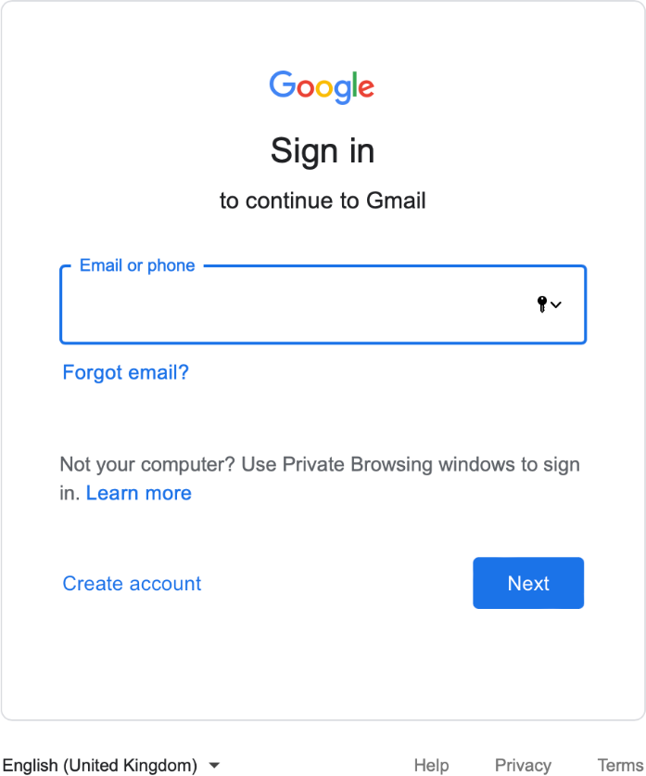Being **based in Google's data centers**, data and information are saved directly and then synchronized to other data centers for backup purposes. Unlike the free, consumer-facing services, Google Workspace users do not see advertisements while using the services, and information and data in Google Workspace accounts do not get used for advertisement purposes. Furthermore, **Google Workspace administrators can fine-tune security and privacy settings**.

In June 2021, Google announced that Workspace would be available "for everyone" with a Google Account, giving consumers access to the upgraded Gmail experience previously only available to paying subscribers.

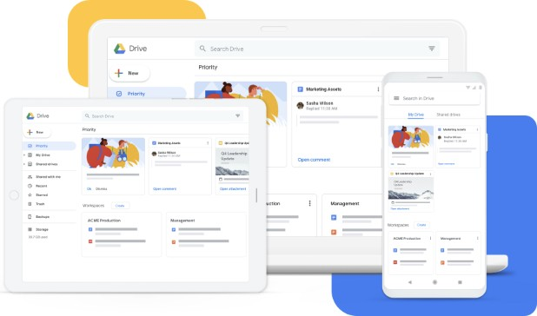As of April 2020, G Suite had 6 million paying businesses, and 120 million G Suite for Education users.

**Google Meet** is a video-communication **software as a service (SaaS)** developed by Google. It is one of two apps that constitute the replacement for Google Hangouts, the other being Google Chat.

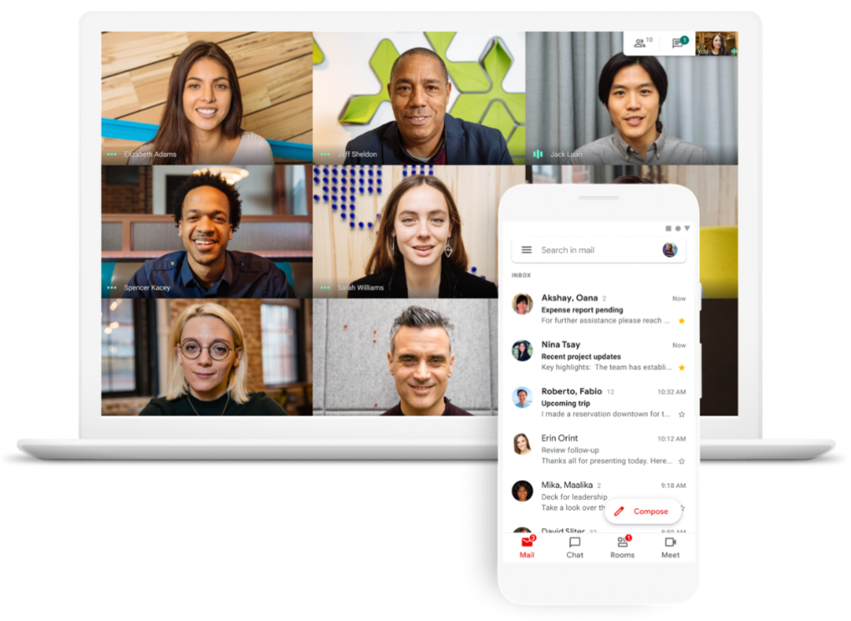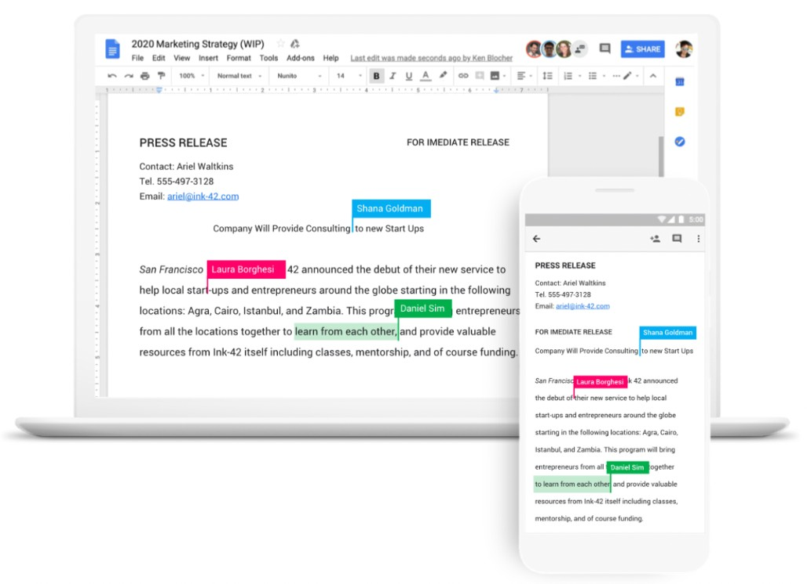**Google Docs** is an online **word processor software as a service (SaaS)** included as part of the free, web-based Google Docs Editors suite o"ered by Google, which also includes Google Sheets, Google Slides, Google Drawings, Google Forms, Google Sites, and Google Keep.

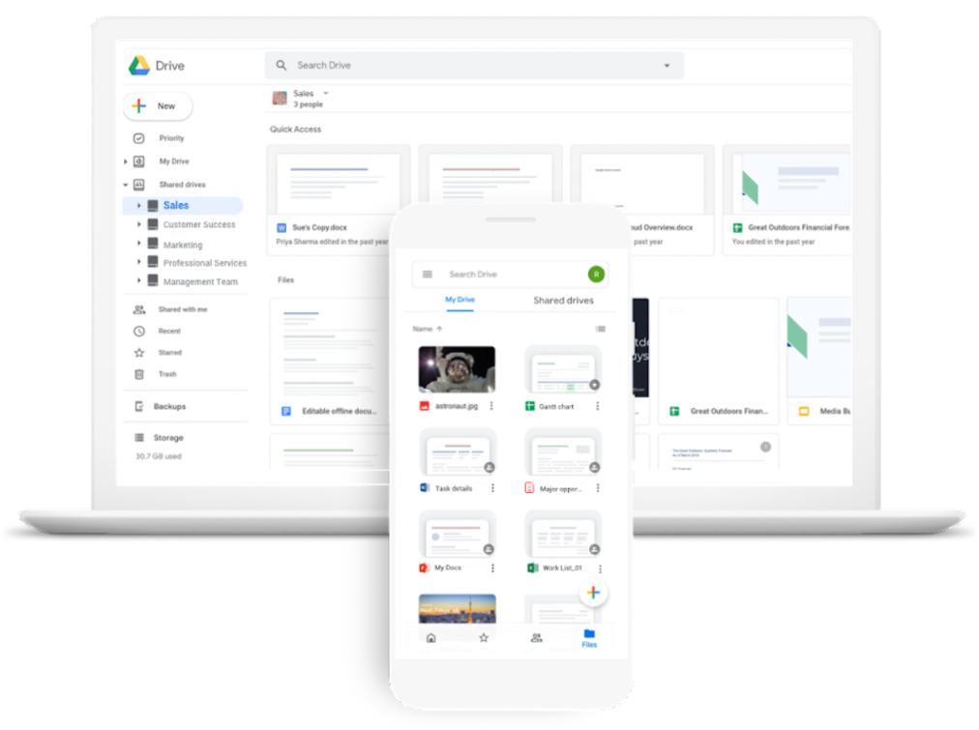**Google Drive** is a **file storage and synchronization service** developed by Google. Launched on April 24, 2012, Google Drive allows users to store files in the cloud, synchronize files across devices, and share files.

**Google Calendar** is a **time-management and scheduling calendar service** developed by Google. It became available in beta release April 13, 2006, and in general release in July 2009, on the web and as mobile apps for the Android and iOS platforms. Google Calendar allows users to create and edit events.

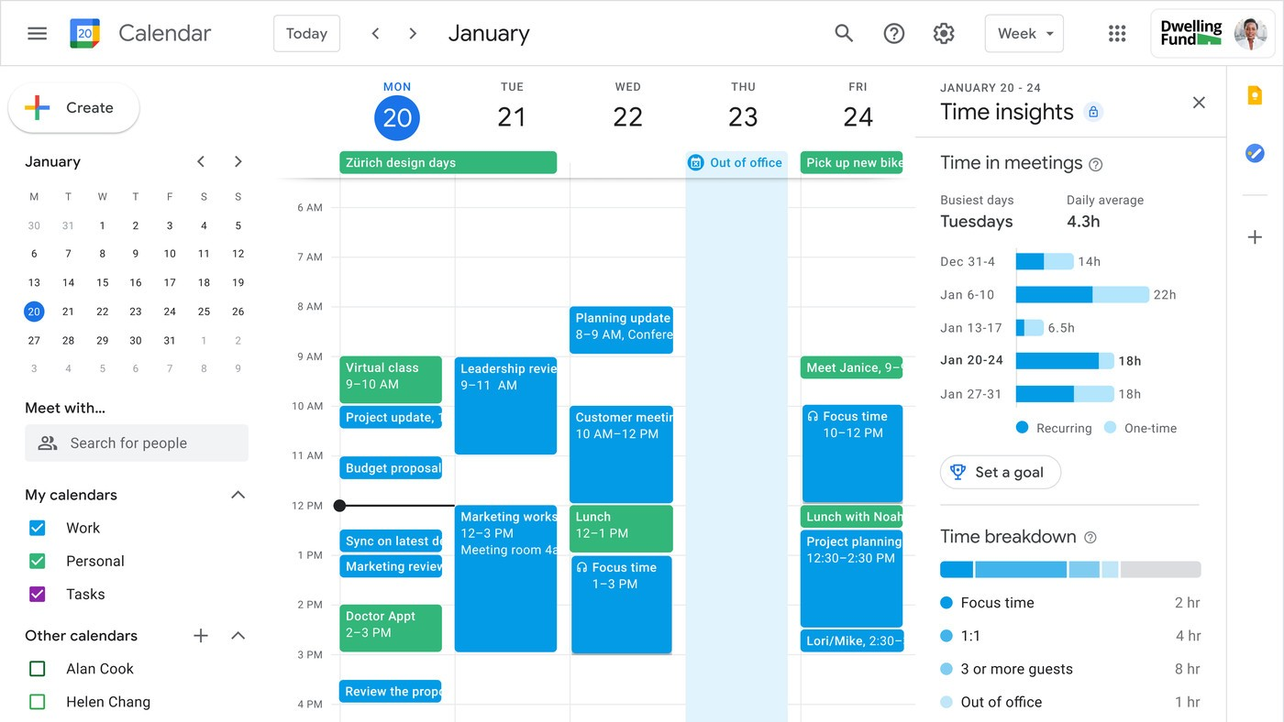

**Gmail** is a **free email service** provided by Google. As of 2019, it had 1.5 billion active users worldwide. A user typically accesses Gmail in a web browser or the okcial mobile app. Google also supports the use of email clients via the POP and IMAP protocols.

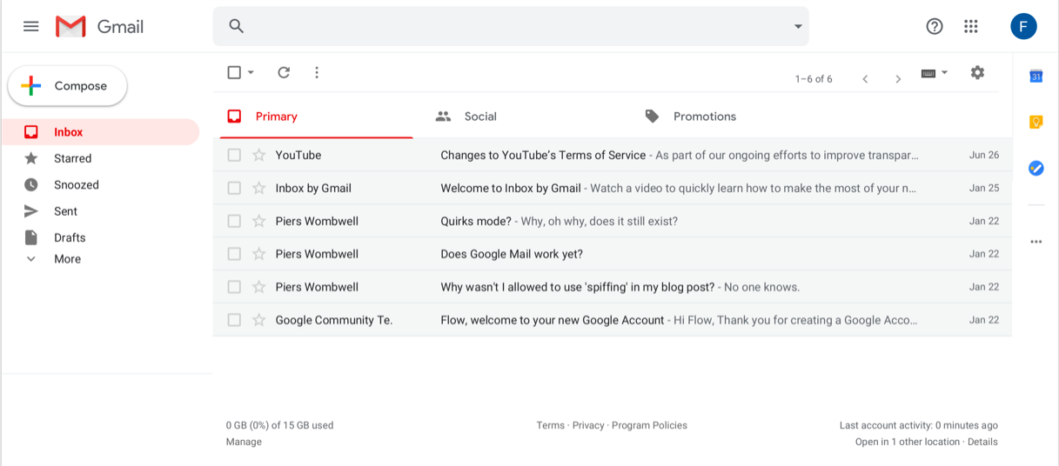

### Security and Privacy

Google states that "we do not collect, scan or use your G Suite data for advertising purposes and do not display ads in G Suite, Education, or Government core services". Furthermore, it states that "the data that companies, schools and government agencies put into our G Suite services does not belong to Google. Whether it's corporate intellectual property, personal information or a homework assignment, **Google does not own that data and Google does not sell that data to third parties**".

Data is stored in Google's data centers, which are "built with custom-designed servers that run our own operating system for security and performance", with "more than 550 full-time security and privacy professionals". In a blog post, Google stated that benefits of using G Suite included "**disaster recovery**", with data and information "simultaneously replicated in two data centers at once, so that if one data center fails, we nearly instantly transfer your data over to the other one that's also been reflecting your actions." Though acknowledging that "no backup solution from us or anyone else is absolutely perfect", Google states that it has "invested a lot of e"ort to help make it second to none".

### Pricing

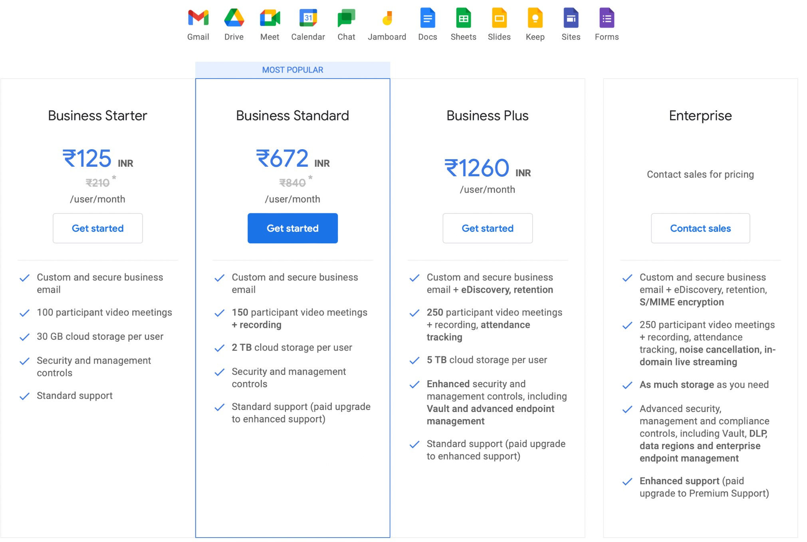

# VMWARE Cloud

### Introduction

VMware, Inc. is an American cloud computing and virtualization technology company headquartered in California. VMware was the first commercially successful company to virtualize the x86 architecture.

VMware's desktop software runs on Microsoft Windows, Linux, and macOS, while its

enterprise software hypervisor for servers, VMware ESXi, is a bare-metal hypervisor that

runs directly on server hardware without requiring an additional underlying operating system.

VMware operated in stealth mode, with roughly 20 employees by the end of 1998. The

company was launched officially early in the second year, in February 1999, at the DEMO Conference organized by Chris Shipley. The first product, VMware Workstation, was delivered in May 1999, and the company entered the server market in 2001 with VMware GSX Server (hosted) and VMware ESX Server (hostless).

In 2003, VMware launched VMware Virtual Center, vMotion, and Virtual SMP technology. 64-bit support was introduced in 2004.

On September 16, 2008, VMware announced a collaboration with Cisco Systems. One result was the Cisco Nexus 1000V, a distributed virtual software switch, an integrated option in the VMware infrastructure.

In April 2011, EMC transferred control of the Mozy backup service to VMware.

On April 12, 2011, VMware released an open-source platform-as-a-service system called Cloud Foundry, as well as a hosted version of the service. This supported application deployment for Java, Ruby on Rails, Sinatra, Node.js, and Scala, as well as database support for MySQL, MongoDB, Redis, Postgres, RabbitMQ.

In May 2013, VMware launched its own IaaS service, vCloud Hybrid Service, at its new Palo Alto headquarters (vCloud Hybrid Service was rebranded vCloud Air and subsequently sold to cloud provider OVH), announcing an early access program in a Las Vegas data center. The service is designed to function as an extension of its customer's existing vSphere installations, with full compatibility with existing virtual machines virtualized with VMware software and tightly integrated networking.

In August 2016 VMware introduced the VMware Cloud Provider website. New branch role is funneling cloud-related information as the central source of cloud provider technology

content.

In August 2017, VMware and Amazon Web Services jointly announced the launch of

VMware Cloud on AWS, a SaaS service delivering a vSphere compatible cloud in an AWS datacenter. VMware has since returned to the “hybrid cloud” naming convention to describe this use of a consistent platform across on-prem and public clouds.

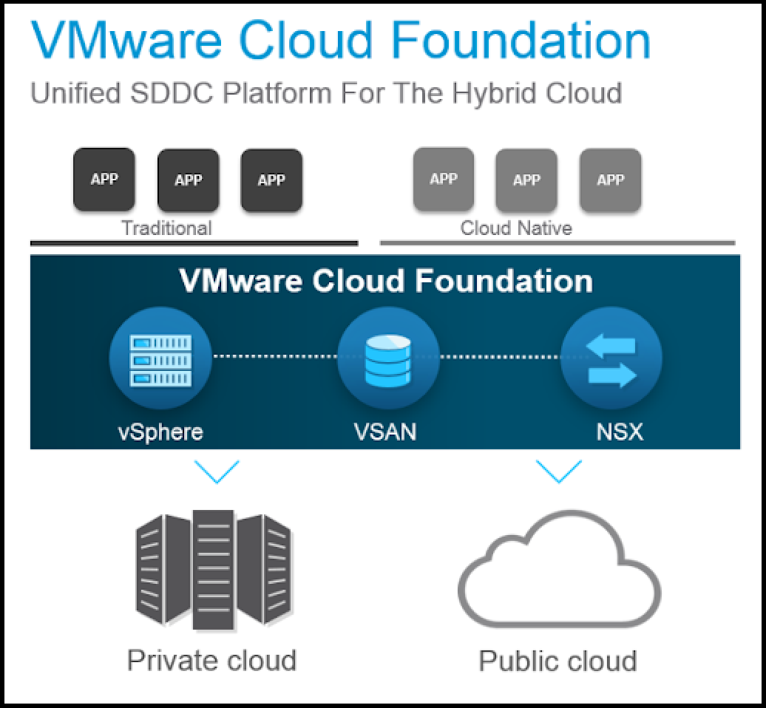

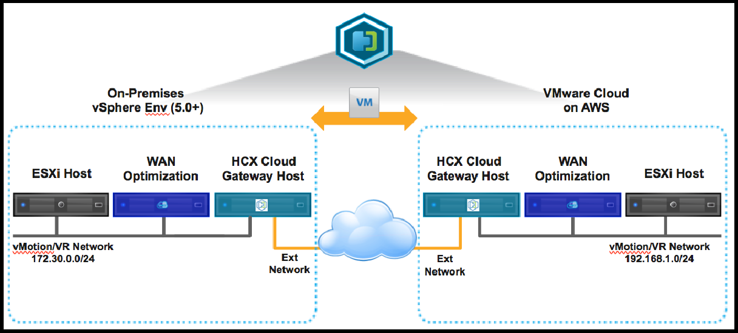

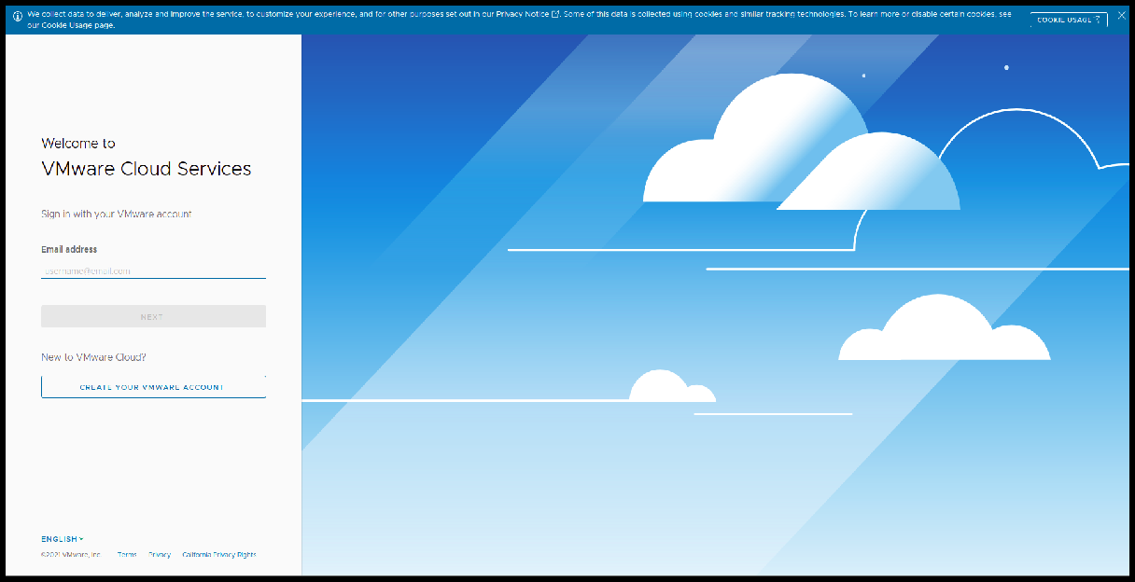

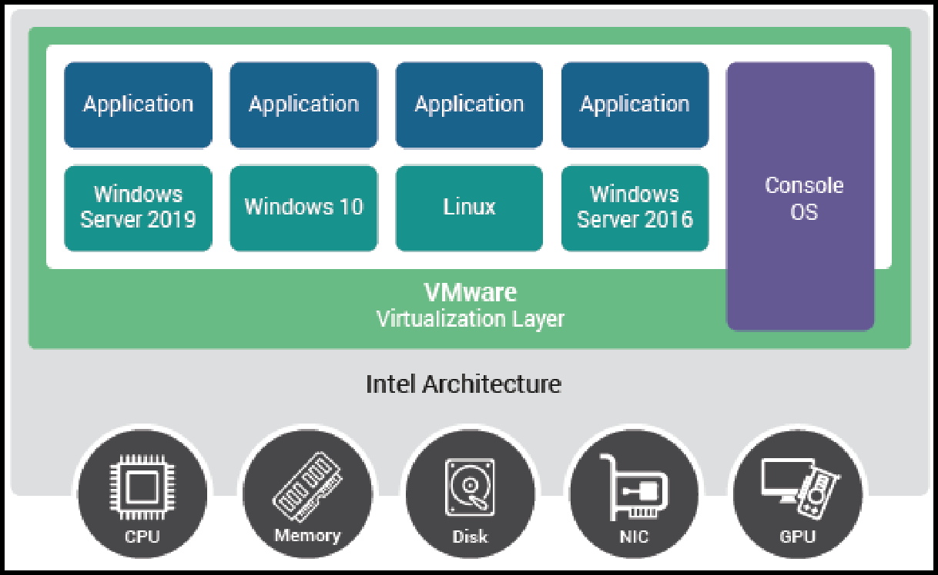

### Cloud Architecture

The VMware vCloud Architecture Toolkit for Service Providers (vCAT-SP) is a set of reference documents for VMware Cloud Providers. It is designed to help IT

managers and architects construct cloud platforms and service offerings using current technologies, recommended practices, and innovative tools.

vCAT-SP provides attested, validated, and optimized design and support solutions with the most efficient examples to help you make the right choices for your business. vCAT-SP is aligned to the most common cloud service models that VMware Cloud Providers are deploying for their customers – hosting, private cloud, and public cloud.

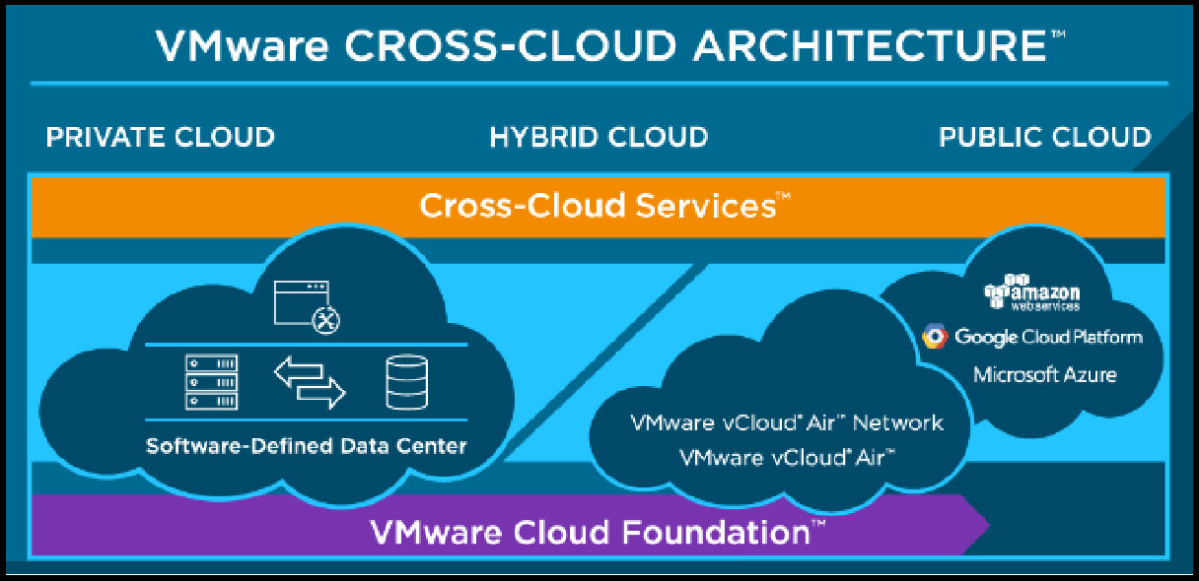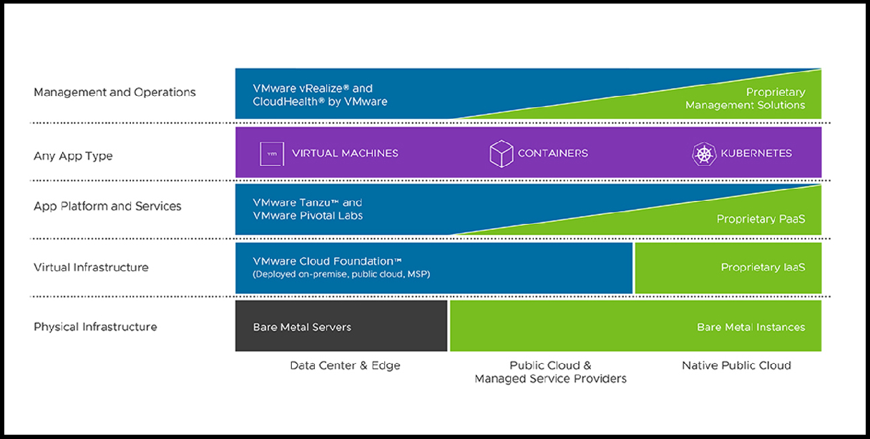

### Virtualization

Virtualization can increase IT agility, flexibility and scalability while creating significant cost savings. Greater workload mobility, increased performance and availability of resources, automated operations – they’re all benefits of virtualization that make IT simpler to manage and less costly to own and operate.

Virtualization relies on software to simulate hardware functionality and create a virtual computer system. This enables IT organizations to run more than one virtual system – and multiple operating systems and applications – on a single server. The resulting benefits include economies of scale and greater ekciency.

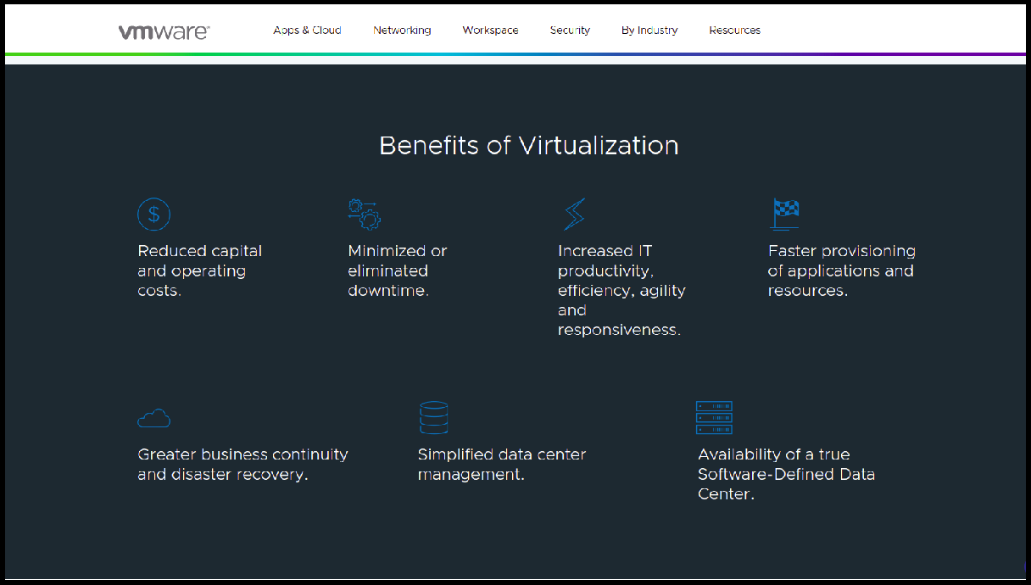

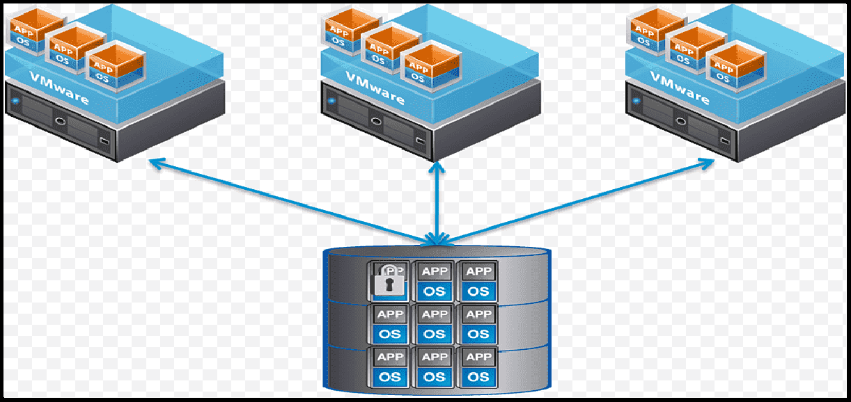

# Amazon Web Services (AWS)

**Amazon Web Services (AWS)** is the world’s most comprehensive and broadly adopted cloud platform, o"ering over **200 fully featured services from data centers globally**. Millions of customers—including the fastest-growing startups, largest enterprises, and leading government

agencies—are using AWS to lower costs, become more agile, and innovate faster

## Highlights

### Most functionality

AWS has significantly more [services](https://aws.amazon.com/products/?pg=WIAWS-mstf), and more features within those services, than any other cloud provider–from infrastructure technologies like **compute, storage, and databases**–to emerging technologies, such as **machine learning and artificial intelligence, data lakes and analytics**, and Internet of Things. This makes it faster, easier, and more cost e"ective to move your existing applications to the cloud and build nearly anything you can imagine.

AWS also has the deepest functionality within those services. For example, AWS o"ers the widest variety of databases that are purpose-built for di"erent types of applications so you can **choose the right tool for the job to get the best cost and performance.**

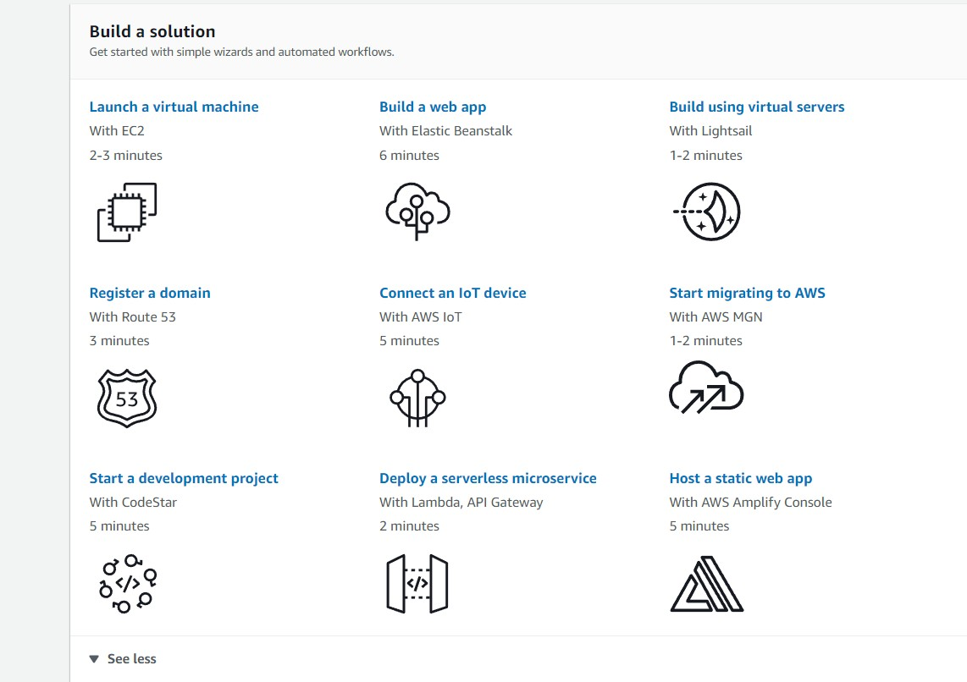

### Largest community of customers and partners

AWS has the **largest and most dynamic community,** with **millions of active customers and tens of thousands of partners globally**. Customers across virtually every industry and of every size, including startups, enterprises, and public sector organizations, are running every imaginable use case on AWS. The AWS Partner Network ([APN](https://aws.amazon.com/partners/?pg=WIAWS-cstp)) includes thousands of systems integrators who specialize in AWS services and tens of thousands of independent software vendors (ISVs) who adapt their technology to work on AWS.

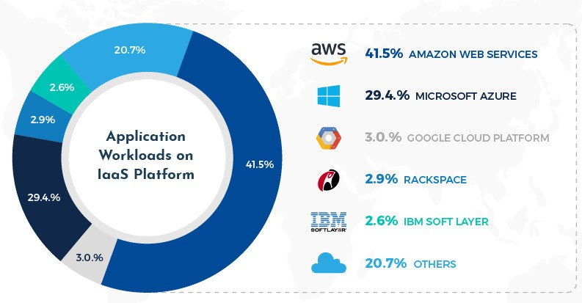

### Most secure

AWS is architected to be the most flexible and secure cloud computing environment available today. Its core infrastructure is built to satisfy the security requirements for the military, global banks, and other high-sensitivity organizations. This is backed by a deep set of cloud security tools, with **230 security, compliance, and governance services and features. AWS supports 90 security standards and compliance certifications, and all 117 AWS services that store customer data oker the ability to encrypt that data.**

## AWS Use Cases

Millions of customers — including the fastest-growing startups, largest enterprises, and leading government agencies — are using AWS to lower costs, become more agile, and innovate faster.

The company o"ers a complete range of **IaaS and PaaS services**. Among the best known are its **Elastic Compute Cloud (EC2), Elastic Beanstalk, Simple Storage Service (S3), Elastic Block Store (EBS), Glacier storage, Relational Database Service (RDS), and DynamoDB NoSQL database.** It also o"ers cloud services related to networking, analytics and machine learning, the **Internet of Things (IoT), mobile services, development**, cloud management, cloud security and more.

In every field, the AWS service is used. Below are some areas and some top companies use AWS.

* + **Aerospace** (NASA, Maxar, ESA etc.)
  + **Gaming** (MPL, FanFight, Gammation etc.)
  + **Education** (Coursera, BYJU’s etc.)
  + **Telecommunication** (Pinterest, Vodafone, Aircel etc.)
  + **Entertainment** (Netflix, Hotstar etc.)
  + **Media** (BBC, The Hindu, Punjab Kesri etc.)
  + **Software** (Share chat, Slack etc.)

## Login and Management

14

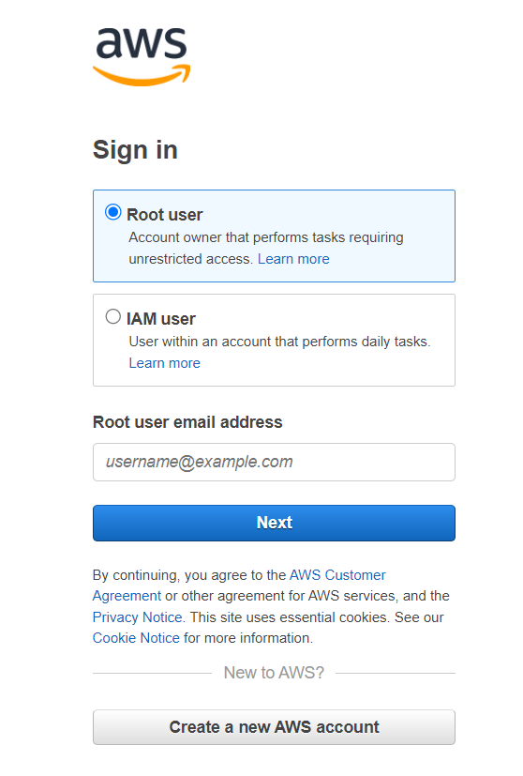

**Console**

First, to avail all the services of AWS, we need to create a **free account.** While creating an account, billing information may also be asked, but no cost will be incurred. These details will just be used further in time, whenever we avail any paid services.

The [**AWS Management Console**](https://console.aws.amazon.com/) is a web application that comprises and refers to a broad collection of service consoles for managing Amazon Web Services. On signing in, the console home page can be seen. The home page provides access to each service console as well as an intuitive user interface for exploring AWS and getting helpful tips.

The individual service consoles, on the other hand, o"er a wide range of tools for cloud computing, as well as information about your account and about your [billing](https://console.aws.amazon.com/billing/).

The [**AWS Management Console**](https://console.aws.amazon.com/) has been designed to work on tablets as well as other kinds of devices:

* Horizontal and vertical space is maximized to show more on your screen.
* Buttons and selectors are larger for a better touch experience.

The AWS Management Console is also available as an app for **Android and iOS.** This app provides mobile-relevant tasks that are a good companion to the full web experience. **For example, you can easily view and manage your existing Amazon EC2 instances and Amazon CloudWatch alarms from your phone.**

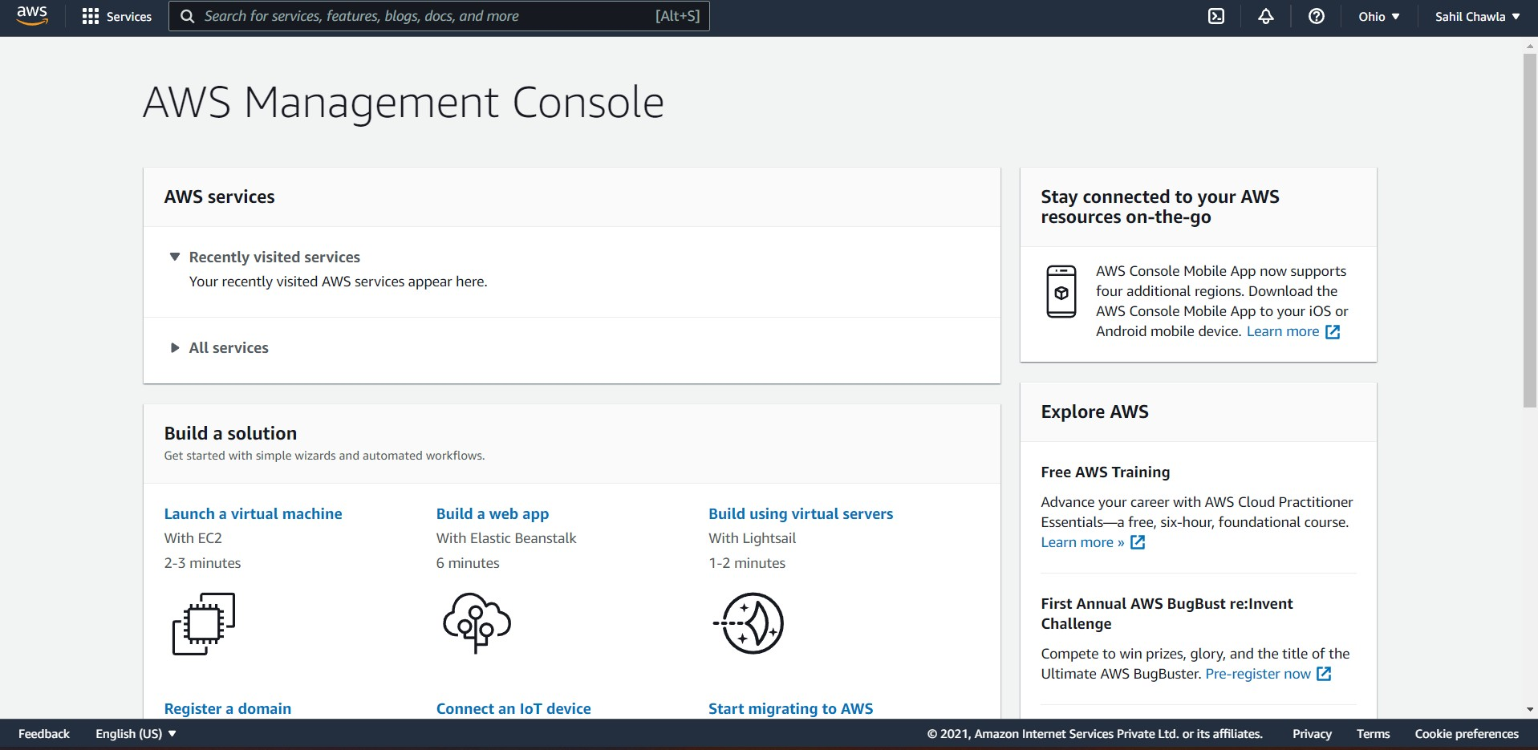

### Billing

The AWS Billing console contains features to organize and report your **AWS cost and usage based on user-defined methods, and manage your billing and control costs.**

The Billing console works closely with the **AWS Cost Managemen**t console so you can holistically manage your costs. The Billing console contains resources to manage your **ongoing payments, while the AWS Cost Management console resources are designed to help you optimize your future costs.**

AWS automatically charges the **credit card that you provided when you signed up** for a new account with AWS. Charges appear on your **monthly credit card bill.** You can view or update your credit card information, including designating a di"erent credit card for AWS to charge, on the Payment Methods page in the Billing console. B**illing provides useful tools to help you gather information related to your cost and usage, analyze your cost drivers and usage trends, and take action to budget your spending.**

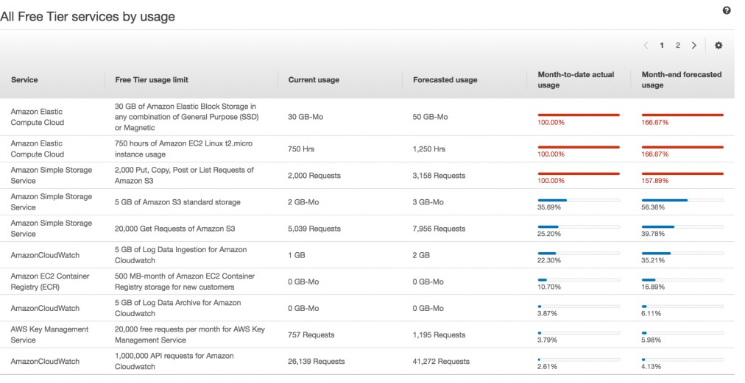

**Example of Billing and Usage screen**

### Related services

**IAM**

The Billing service and AWS Cost Management service is tightly integrated with **AWS Identity and Access Management (IAM).** Y**ou can use IAM with Billing to ensure that other people who work in your account have as much access as they need to get their jobs done.**

**You also use IAM to control access to all of your AWS resources**, not just your billing information. It's important that you familiarize yourself with the basic concepts and best practices of **IAM before you get too far along with setting up the structure of your AWS account.**

**AWS Organizations (Consolidated Billing)**

**AWS products and services are designed to accommodate every size of company, from small start-ups to enterprises.** If your company is large or likely to grow, you might want to set up multiple AWS accounts that reflect your company's structure. For example, you can have one account for the entire company and accounts for each employee, or an account for the entire company with IAM users for each employee. **You can have an account for the entire company, accounts for each department or team within the company, and accounts for each employee.**

If you create multiple accounts, you can use the **consolidated billing feature of AWS Organizations to combine all member accounts under a management account, and receive a single bill.**

### Extensive Documentation

The AWS Documentation is one of the most extensive documentations, and has easy-to-surf through content, ranging from account management, to satellite operations, every topic related to AWS can be found here and referred to.

Also, it is open source on github for any contributions.

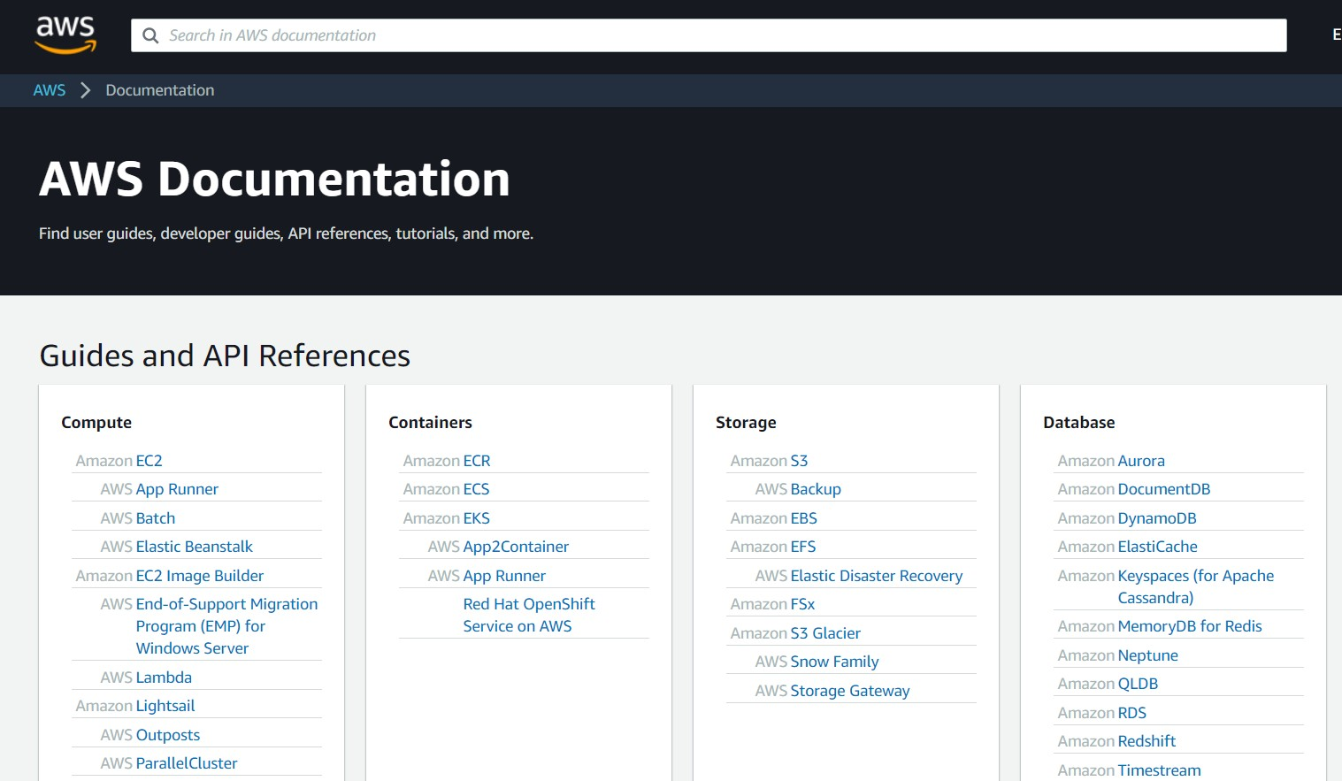

# Microsoft Azure

### Introduction

**Microsoft Azure**, often referred to as **Azure** is a cloud computing service operated by Microsoft for application management via Microsoft-managed data centers. It provides **software as a service (SaaS)**, **platform as a service (PaaS)** and **infrastructure as a service (IaaS)** and supports many di"erent programming languages, tools, and frameworks, including both Microsoft-specific and third-party software and systems.

#### Services

Azure o"ers a large amount of services (more than 600), using large-scale virtualization at Microsoft data centres worldwide.

These services include -

* Virtual machines, infrastructure as a service (IaaS) allowing users to launch general-purpose Microsoft Windows and Linux virtual machines, as well as preconfigured machine images for popular software packages,
* App services, platform as a service (PaaS) environment letting developers easily publish and manage websites,
* Azure Active Directory, used to synchronize on-premises directories and enable SSO (Single Sign On),
* Mobile Engagement, which collects real-time analytics that highlight users’ behavior and also provides push notifications to mobile devices,
* Storage Services providing REST and SDK APIs for storing and accessing data on the cloud,
* Azure Communication Services, which o"ers an SDK for creating web and mobile communications applications that include SMS, video calling, VOIP and PSTN calling, and web based chat,
* Azure Data Explorer providing big data analytics and data-exploration capabilities,
* Microsoft Azure Machine Learning (Azure ML) providing tools and ML frameworks for developers to create their own machine learning and artificial intelligence (AI) services,
* Azure Orbital, a ground station service to help customers move satellite data to the cloud and to provide global cloud connectivity.

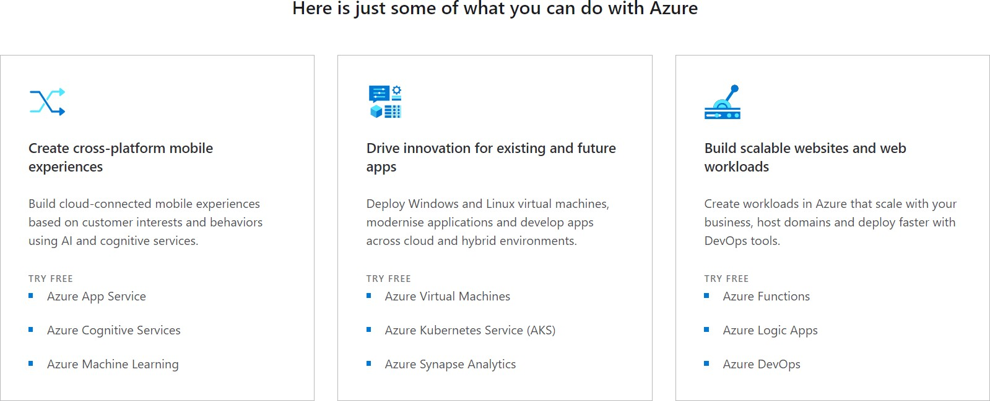

### Login and Portal

Login is handled through **Microsoft accounts**, allowing you to utilize the same account you may use for Windows, or OneDrive. However, as an added security measure, Two step verification using OTPs is conducted during registration. Billing information is also required, however only a minimal amount is deducted (one-time payment), and no further deductions are conducted unless the user activates the required settings.

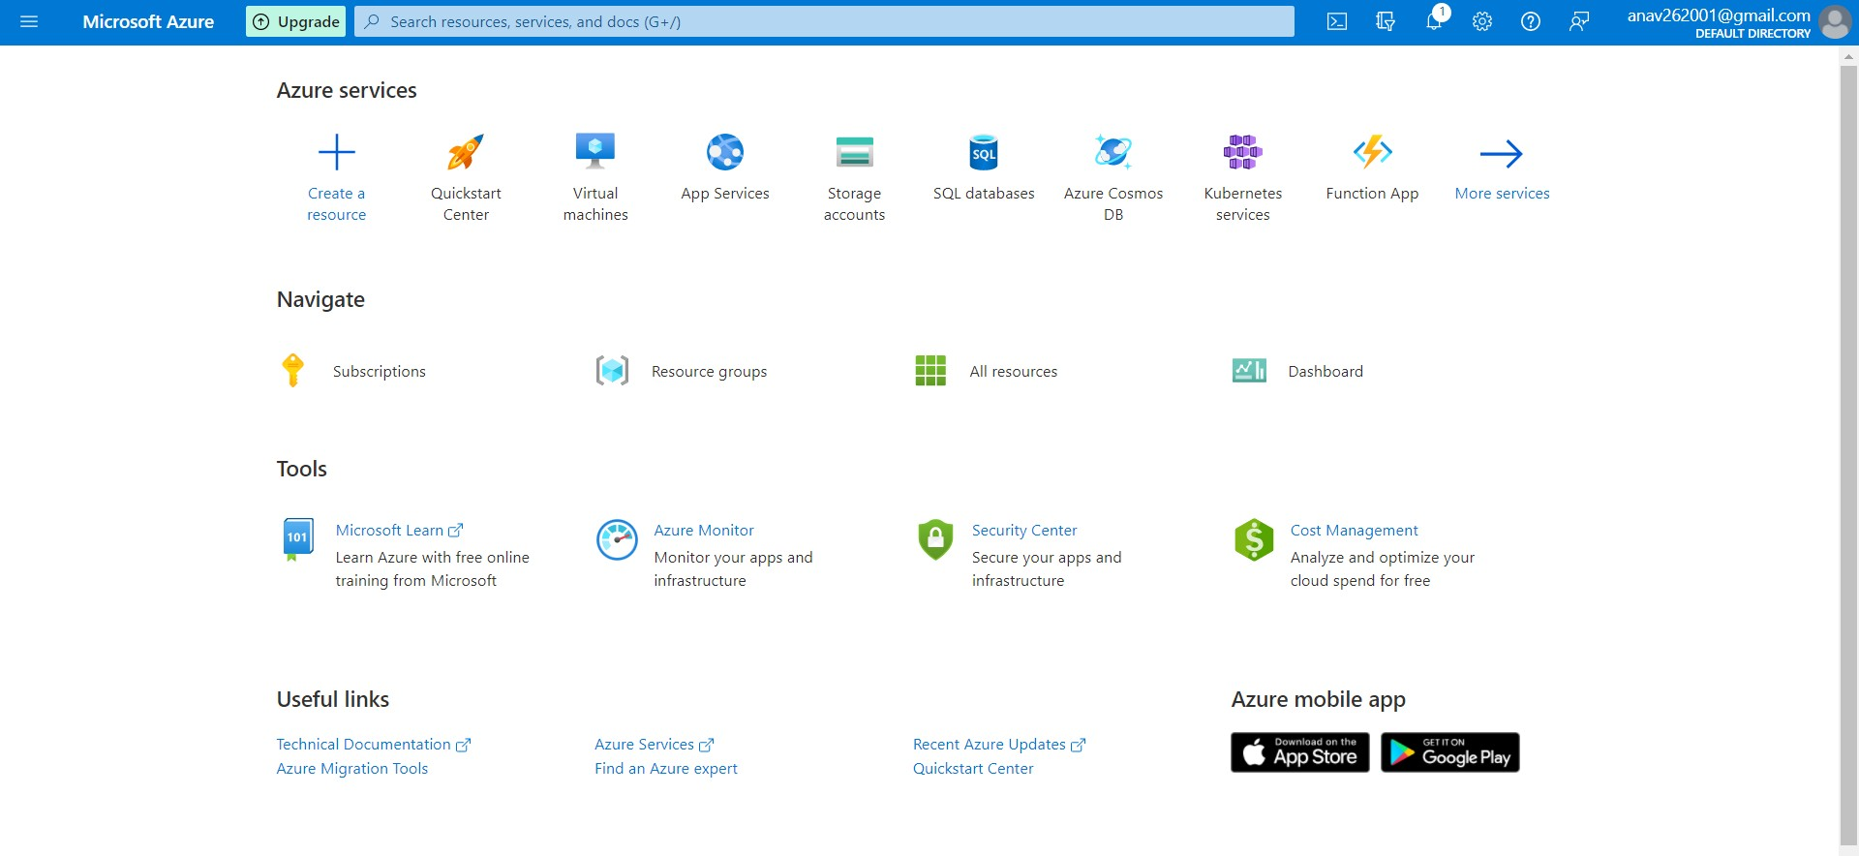

Once logged in, the user is brought to the **Azure Portal**, which acts as the dashboard for Microsoft Azure, and provides quick access to multiple o"erings.

### Design and Deployment Model

Azure uses a specialized operating system, called Microsoft Azure, to run its **"fabric layer"**: a cluster hosted at Microsoft's data centers that manage computing and storage resources of the computers and provisions the resources (or a subset of them) to applications running on top of Microsoft Azure. Microsoft Azure has been described as a **"cloud layer"** on top of a number of Windows Server systems, which use **Windows Server 2008** and a customized version of **Hyper-V**, known as the Microsoft Azure Hypervisor to provide virtualization of services.

Scaling and reliability are controlled by the **Microsoft Azure Fabric Controller**, which ensures the services and environment do not fail if one or more of the servers fails within the Microsoft data center, and which also provides the management of the user's Web application such as memory allocation and load balancing.

Microsoft Azure o"ers two deployment models for cloud resources: the **"classic" deployment model** and the **Azure Resource Manager**. In the classic model, each Azure resource (virtual machine, SQL database, etc.) was managed individually. The Azure Resource Manager, introduced in 2014, enables users to create groups of related services so that closely coupled resources can be deployed, managed, and monitored together.

### Services

Below is an in-depth look at some important Services o"ered by Microsoft Azure, namely, the QuickStart Centre, Virtual Machines, App Services and AI and Machine Learning Services

#### QuickStart Centre

The QuickStart Centre allows users to rapidly set up certain popular services, and learn how to engage with each service individually. It allows users to rapidly setup WebApps, Container-Based Apps, Databases, Data Analytics, Machine Learning, and even deploy Virtual Machines at the click of a button.

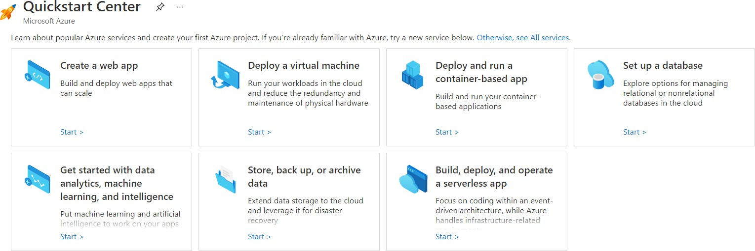

##### Virtual Machines

Azure allows users to quickly create and manage multiple virtual machines, which can be individually customized. Customization options include Disk type (SSDs premium or standard, and HDDs) and encryption, Network Security, IP, and inbound ports, VM applications and extensions, and a myriad of Operating Systems (including Windows 10, Windows Server and multiple distros of Linux including Debian, RedHat and Ubuntu Server) to choose from.

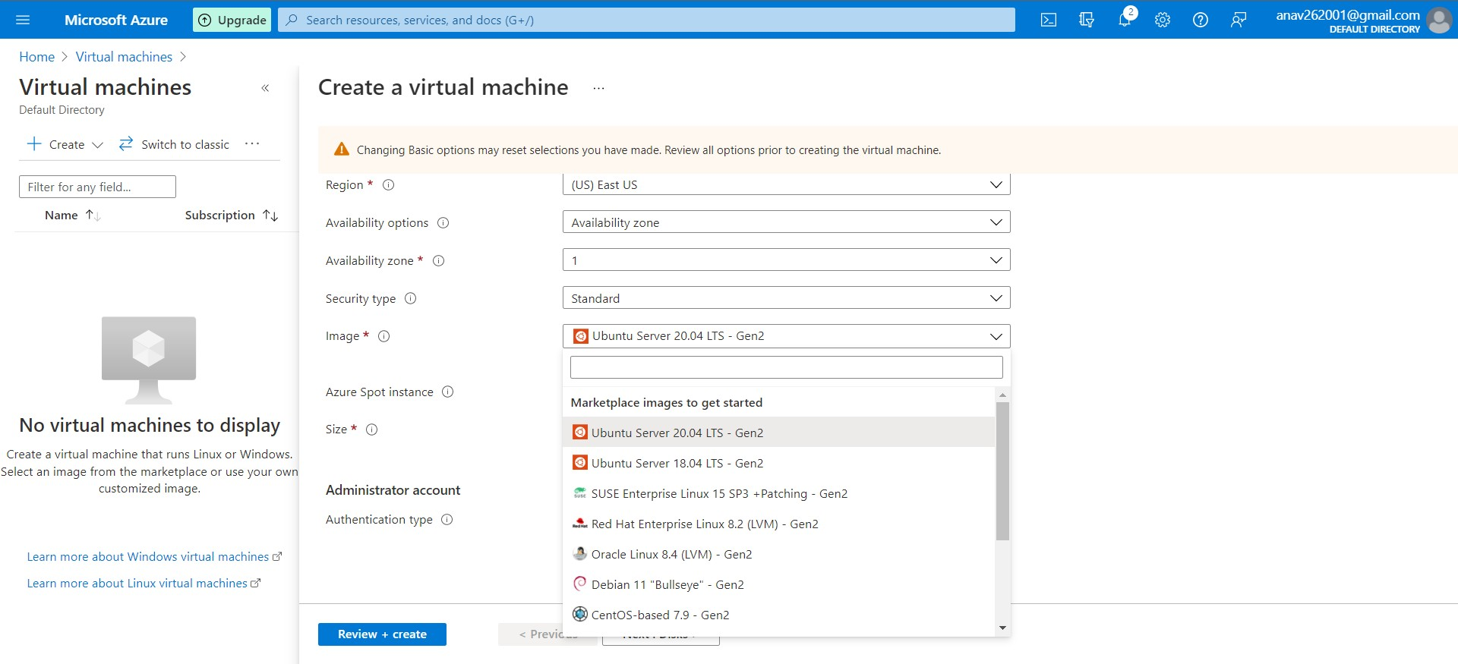

#### App Services

Users can rapidly deploy web applications using Azure App Services. App Services allows users to deploy both Code Based and Docker Container Apps, using multiple runtime stacks including

.NET, Java, Node, Python and Ruby. Certain runtime stacks also support continuous deployment through GitHub which can be configured using GitHub Actions. App Services also includes Azure Monitor application insights, which is an Application Performance Management (APM) service for developers and DevOps professionals. It detects performance anomalies, and includes powerful analytics tools to help diagnose issues and to understand what users actually do with the app.

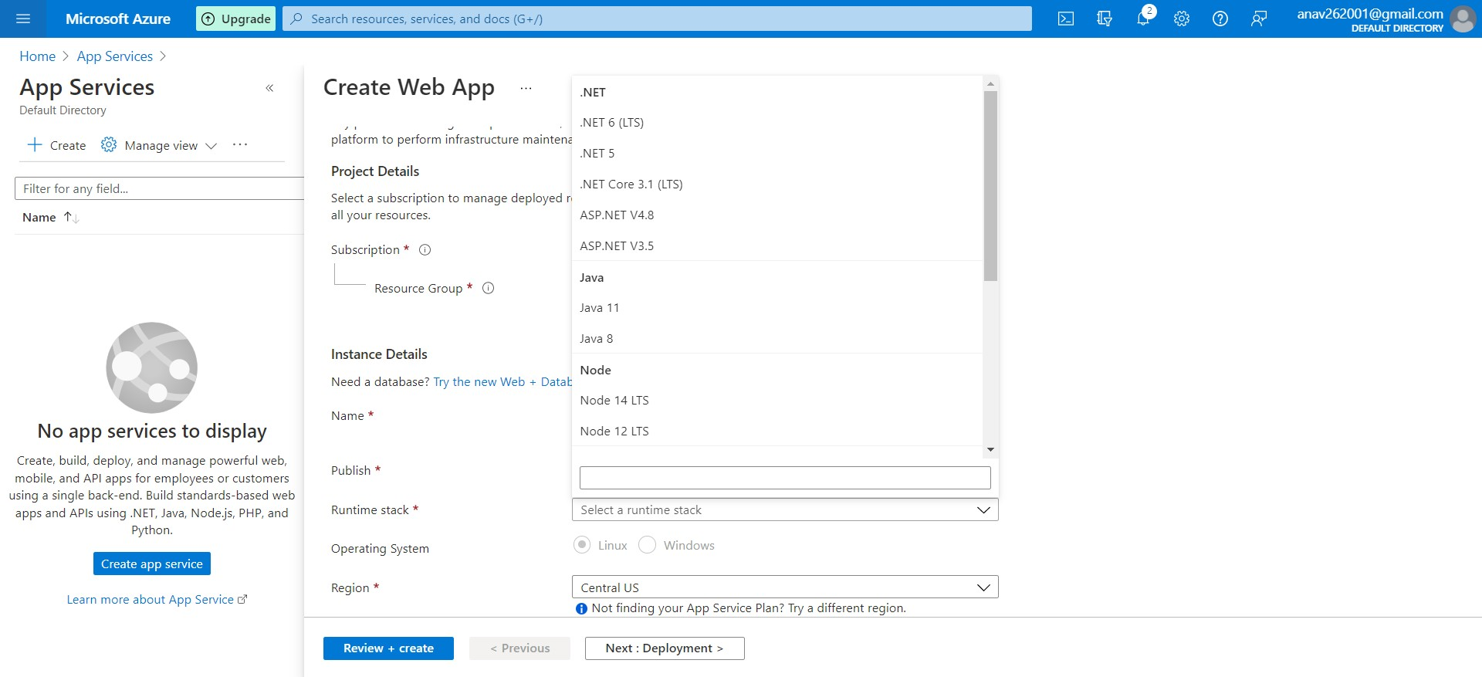

#### AI and Machine Learning

Azure o"ers 26 AI and Machine Learning Services which range from Computer Vision, Form Recognizers, NLP, Machine Learning Workspaces, Face APIs, Speech Services and Translators. Each Service is incredibly easy to set up and is highly customizable to suit the needs of the user. Azure also o"ers Data Analytics as a separate suite of 15 services.

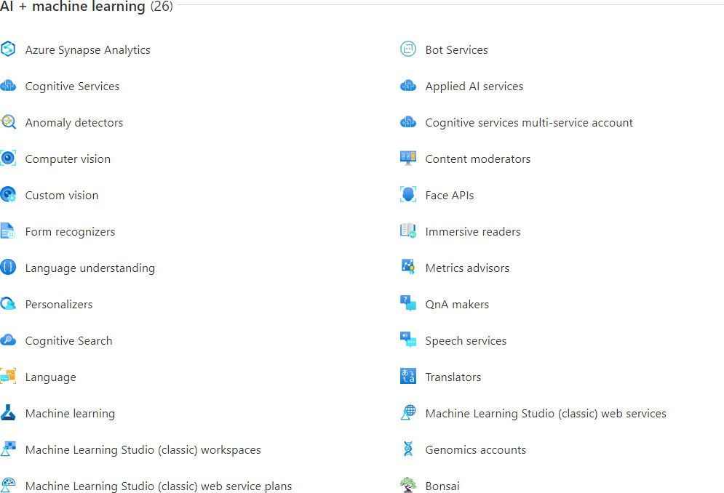

### Pricing

Azure o"ers a robust pricing system where you can customize your pricing model to cover only the applications which you need, with individual pricing for each service provided separately. For example, with respect to Virtual Machines, pricing varies based on the number of Cores, amount of RAM, and amount of Temporary Storage. Given the highly customizable nature of the pricing model, Azure o"ers a dedicated Pricing Calculator, which users can use to easily figure out the pricing model that suits their individual needs.

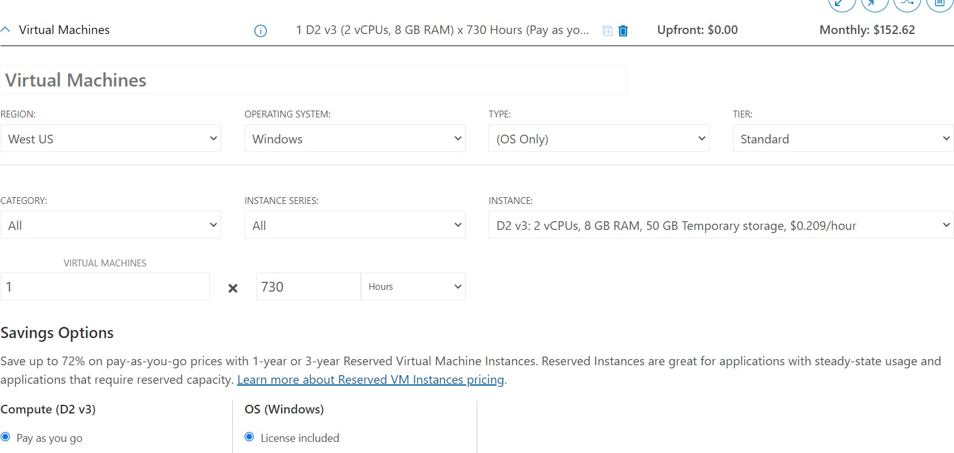

# Meghraj

### Introduction

**Meghraj is the cloud service provided by the Government of India through National Informatics Centre Services (NICS)** under its GI cloud (Government of India Cloud) initiative. It was developed with the aim of providing cloud services through a common platform to all the government okcials and departments at every level of government, from the central to the local level, so that the push towards e-governance under Digital India initiative is facilitated. A common cloud platform can enable local governments and its instrumentalities to adopt e-Governance for rendering better citizen services, without requiring the setting up of significant IT infrastructure.

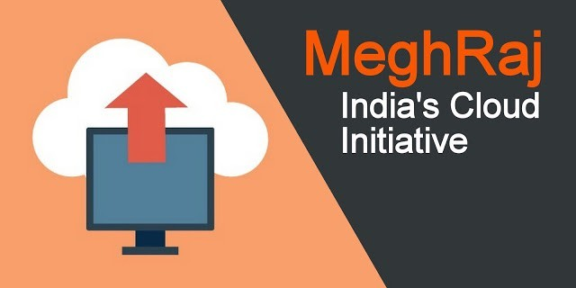The National Cloud Initiative also presents an opportunity for India’s Information Technology (IT) & IT Enabled Services (ITeS) sector by opening up a new avenue of providing Cloud-based services to global organizations ranging from Software as a Service (SaaS) based application services, providing remote testing and

prototyping services in addition to remote application hosting services such as Platform as a Service (PaaS) and Infrastructure as a Service (IaaS).

Since it was researched upon about its cost benefits, challenges and feasibility by TRAI in 2012, envisioned in 2013 through two papers by the GOI (GI Cloud (Meghraj) Strategic Direction Paper and GI Cloud (Meghraj) Adoption and Implementation Roadmap) and launched in 2014, it is still growing and being worked upon actively under the Department of Electronics and Information Technology (DeitY). So far, NIC has set up Data Centres at Delhi, Hyderabad, Pune and is in the process of setting up a National Data Centre at Bhubaneswar. Besides this, mini Data Centres are operational in all NIC State Centres to cater to the e-Governance requirements at the state level. These Data Centres provide round-the-clock operations and management of systems with onsite skilled personnel. Currently, there are 11 CSPs empanelled with the GoI for providing cloud computing services to government departments which include Microsoft Corporation, Hewlett Packard, IBM India, Tata Communications, Bharat Sanchar Nigam Limited (BSNL), Net Magic IT Services, Sify Technologies and CtrlS Data Centers. As of December 16, 2017, Amazon Web Services (AWS) has already been empanelled, while Microsoft and IBM were added by the third

week of December (2017). Bharti Airtel and Reliance Jio — the other two companies are in the process of getting empanelled with the government as CSPs.

### Deployment Model

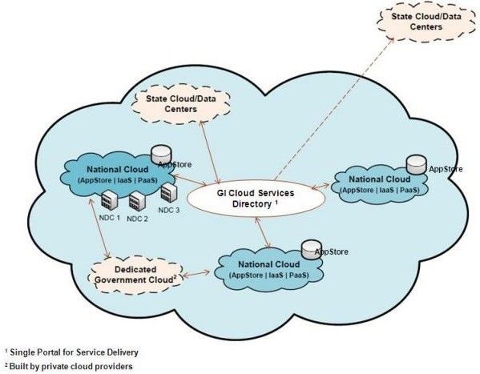Meghraj is primarily a community cloud deployment with the resources in the data centers on premises owned either by NICS - the cloud service provider - or some other 3rd party whose existing infrastructure has been

incorporated into the program to be used for provisioning through the cloud. Access to the cloud resources is available through a secured Virtual Private Network and multi-location cloud based on nodes setup all across india. All the cloud service users (CSUs) - government entities - broadly share a common security policy and guidelines for operation and work towards a shared objective following a set of common protocols and standards.

While new (augmented) infrastructure is being added, primarily, the GI cloud is envisioned to consist of multiple National and State Clouds.

### Services Okered

##### Platform as a Service (PaaS) :

PaaS provides pre-installed web and database servers so that users can publish and run web applications without worrying about server setup. The servers are pre configured ready with basic security hardening. PaaS services quickly deploying servers and publishing web applications. The OS & Application Software licenses are provided by the cloud service provider (CSP) as part of o"ering.

##### Infrastructure as a Service (IaaS) :

IaaS provides users with basic virtual compute infrastructure resources like CPU, Memory, Disk Storage attached to blank VMs allowing installations of OS, using ISOs, from scratch and customizations. However users have to use their own licenses for OS and Application software (if any).

##### Software as a Service (SaaS) :

This provides on demand software service. SaaS is a software delivery model where users are not responsible for supporting the application or any of the components. The server infrastructure, OS and software is being managed by cloud services. If clients have a web application and want to distribute it to users, using this cloud service allows them to deliver it through Software as a Service.

##### Storage as a Service (STaaS):

This provides clients with on demand storage of various types including file storage and block storage etc. File and Block storage are methods to store data on NAS and SAN storage systems. Each storage volume can be treated as an independent disk drive and it can be controlled by an external server operating system.

##### Load Balancer as a Service :

Load balancing Service allows clients to ekciently get incoming network trakc requests distributed across a group of back-end servers (e.g. server farm / server pool). This service is available on demand for critical applications requiring high availability and easy workload manageability.

##### Resource Monitoring as a Service :

This service helps users monitor the cloud resources utilization and its availability by allowing the analysis of the utilization trends for critical server resources like CPU, Memory, Network I/O etc. This helps them for better capacity planning and providing a better end-user experience.

##### Backup Service :

This service allows clients to backup the data and application code lying inside the cloud servers based on various parameters like frequency, retention period etc.

##### Data Analytics (DA) as a Service :

Data Analytics as a service (DA-SaaS) refers to the provision of analytics software and operations through web-delivered technologies. These types of solutions o"er businesses an alternative to developing internal hardware setups just to perform business analytics.

##### Agile as a Service :

Agile development is a combination of frameworks, tools and software practices adopted by self-organizing teams for delivering fast paced user centric software solutions. Practices and frameworks touch upon all the aspects of software development from planning (Scrum) to deployment and monitoring (DevOps).

##### Load Testing as a Service :

Load Testing helps in validating the application design and server infrastructure for expected concurrent user load wherein the system’s response is tested under varying load conditions simulating concurrent virtual users accessing the application under test.

##### Artificial Intelligence as a Service :

Artificial Intelligence (AI) is the simulation of human cognitive processes by machines. For this machine learns from data, both structured and

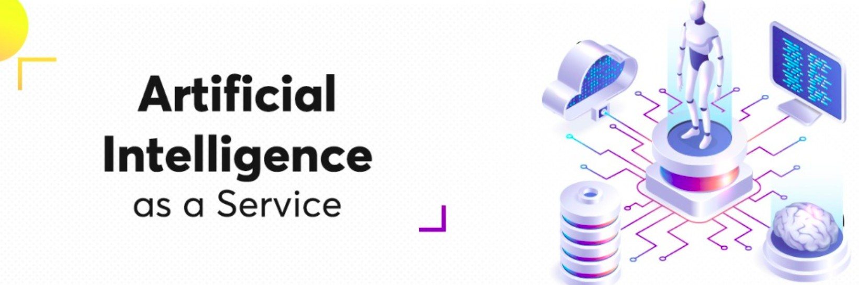unstructured. AI models can be built using supervised learning, or semi-supervised learning, where the system can be used to search for patterns in the data and cluster them, and in the next stage use such classes for further model training. However, usually users don't have the

necessary resources to harness AI because data crunching is a computationally intensive job. This service aims to ease this burden by running these costly computations on the cloud infrastructure.

##### S3WaaS: Website as a Service :

Website as a Service (WaaS) provides website design, development, hosting, maintenance and updates services through S3WaaS. S3WaaS – Secure, Scalable and Sugamya Website as a Service is aimed at providing GIGW compliant, intuitive, user friendly, high quality, and customizable websites to Government entities. The SaaS model has been developed to Create, Deploy, Configure and Manage Accessible websites without much e"ort and technical knowhow. The S3WaaS framework has been deployed on the infrastructure provided by the NIC Cloud.

### Recently Hosted e-Gov Applications on NIC Cloud

* PM-Kisan Samman Nidhi (Department of Agriculture and Farmer Welfare)
* Sakhi Dashboard (Ministry of Women and Child Development)
* eHRMS (Human Resources Management System, GOI)
* Ministry of Micro, Small and Medium Enterprises Website
* Armed Forces Medical Services Website
* Department of Science and Technology Website

### Hands-On Experience

